Hema–Benz SAFETY DATA SHEET

Conditions to Avoid: Extreme heat and free radical initiators.

SECTION XI - TOXICOLOGICAL INFORMATION
Acute Toxicity: ID oral rat. 2,000 mg/kg
Ames Test: Negative. Acrylates can cause sensitization reactions.

SECTION XII - ECOLOGICAL INFORMATION
Waste may be considered as inert material.

SECTION XIII - DISPOSAL CONSIDERATION
Spill Management: Use absorbent to collect the material. Wash contaminated surfaces with soap and water.

SECTION XIV - TRANSPORT INFORMATION
Stable under normal conditions of use, transportation, and storage.

SECTION XV - REGULATORY INFORMATION
510k # K953405

SECTION XVI - OTHER INFORMATION
WARNING! Avoid contact with eyes, skin, and mucous membranes. If accidental contact occurs, FLUSH IMMEDIATELY WITH WATER. CONSULT PHYSICIAN IMMEDIATELY IF EYE CONTACT OCCURS. Keep away from children.

The data and information given in this SDS are accurate on the date of preparation. It does not indicate any warranty or representation. We disclaim all liability relating to use of this material since this is beyond our control.

Healthdent’l L.L.C.

115 E. Ogden Ave. Suite 117-322
Naperville, Illinois 60563 USA
Phone 1-800-845-5172

Desensitizer with Fluoride
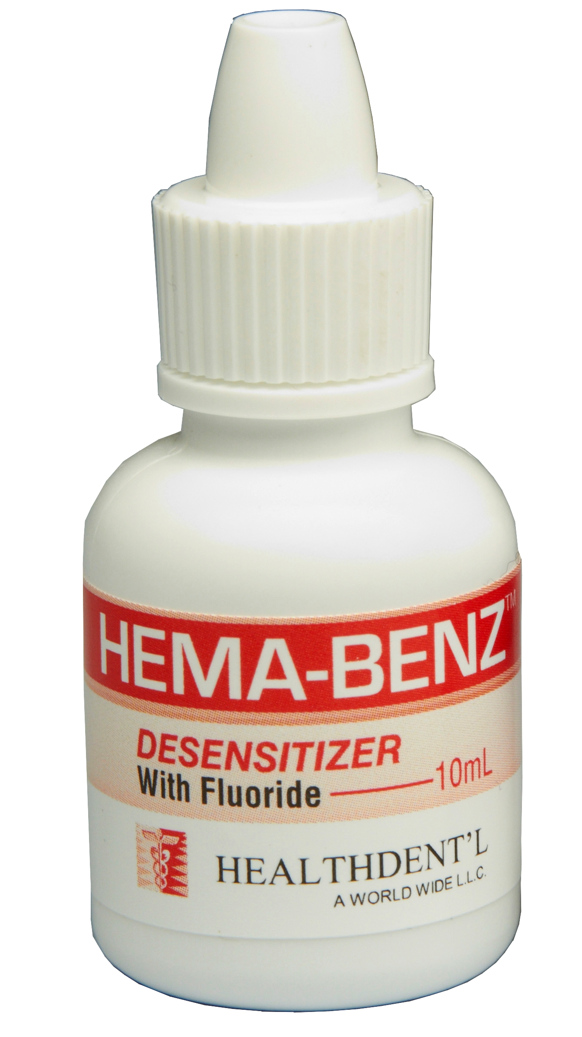
Hema–BenzTM

INSTRUCTIONS

Hema–Benz TM is a superior desensitizing agent, to be placed under dental cements or other restorative materials – temporary, provisional or final. Hema–Benz can be used for desensitization of amalgam restorations, either conventional or bonded. Hema–Benz helps kill bacteria, alter nerve responses and aids bonding primers in penetrating etched dentin.

GENERAL INFORMATION
Hema–Benz contains Benzalkonium chloride and HEMA as well as a small amount of sodium fluoride as an added source of fluoride ion.

WITH GLASS IONOMER AND ZINC PHOSPHATE CEMENTS
Hema–Benz is very effective when applied to vital crown preparations prior to luting with these cements. It may also be used at the “prep” appointment to desensitize during temporization. When Hema–Benz is used properly in conjunction with these cements, complete desensitization will result in nearly all preparations.

WITH RESIN ADHESIVES
Most dentin bonding materials such as All Bond 2, Tenure, Optibond, Scotchbond

MP, Photo Bond, etc. will benefit from Hema–Benz application. The application of

Hema–Benz reliably reduces post-op sensitivity by supporting the collagen framework for easier penetration of the adhesive, thus enhancing the dentin bond.

WITH AMALGAMS
Hema–Benz can be used to eliminate post-op sensitivity under standard amalgam restorations.

NON-BONDED RESTORATIONS
- Clean tooth prep area.
- Dry with air (dryness is not critical).
- Apply Hema–Benz to dried tooth using brush or cotton pellet. Avoid soft tissue.
- Wait 30 seconds, then dry with air.
- Place restorative material such as amalgam, castings, etc. (Zinc phosphate and glass ionomer cements work well with Hema–Benz.)

Hema–Benz INSTRUCTIONS

BONDED APPLICATIONS
- Clean tooth prep area.
- Etch with 10 - 40% phosphoric acid for 15 to 30 seconds.
- Rinse.
- Dry with air (dryness is not critical).
- Apply Hema–Benz, using brush or cotton pellet. Avoid soft tissue.
- Wait 30 seconds, then dry or leave moist, per manufacturer’s instructions for the bonding agent.

7a. Direct restorations: Apply composite bonding agent and composite per manufacturer’s instructions.

7b. Indirect restorations or sealing preparation: Apply composite bonding agent and luting resin per manufacturer’s instructions.

STORAGE AND SHELF LIFE
Expiration date is placed on each Hema–Benz bottle. Hema–Benz has a three year shelf life when kept below 25^{O}C/77^{O}F.

 | Hema–Benz | SAFETY DATA SHEET
SECTION I - PRODUCT IDENTIFICATION
Company: |  | Healthdent’l L.L.C.
 |  | 115 E. Ogden Ave. Suite 117-322
 |  | Naperville, Illinois 60563
Phone: |  | 1-800-845-5172
Prepared: |  | April 15, 2015

SECTION II - HAZARD(S) IDENTIFICATION
OSHA Permissible Exposure Limits: None Other Exposure Limit Used: None ACGIH Threshold Exposure Limit: None Chronic, Other: None

Acute Overexposure: Irritation to eyes and skin. May cause chemical burn. Medical Conditions Generally Aggravated by Exposure: None Known Hygienic Practices: None

Primary Route(s) of Exposure: Skin, eye, ingestion.

SECTION III - COMPOSITION/INFORMATION ON INGREDIENTS

Material | % WGT | OSHA PEL | ACGIH TLV
Benzalkonium Chloride | 1-5% | 0.2 ppmv | 0.2 ppmv
Hydroxylethyl Methacrylate | 25-45 | NA | NA
Sodium Fluoride | 10 ppm | NA | N/A
Water | Balance

(ND = Not Determined NA = Not Applicable NL = Not Listed)

Hema–Benz SAFETY DATA SHEET

SECTION IV - FIRST-AID MEASURES
Skin: Wash off affected area with soap and water.
Ingestion: Seek immediate medical advice, carry container with label. Eyes: Rinse immediately with plenty of water and seek medical advice.

SECTION V - FIRE-FIGHTING MEASURES
Flashpoint: >+ 104 ⁰C
Extinguishing Media: Carbon Dioxide, Foam, Dry Chemical
Special Fire Fighting Procedures: None
Flammable Limits: NA
Unusual Fire and Explosion Hazards: None

SECTION VI - ACCIDENTAL RELEASE MEASURES

Avoid contact with eyes, skin, and mucous membranes. If accidental contact occurs, FLUSH IMMEDIATELY WITH WATER. CONSULT PHYSICIAN IMMEDIATELY IF EYE CONTACT OCCURS. Keep away from children.

SECTION VII - HANDLING AND STORAGE
Spill Management: Use absorbent to collect the material. Wash contaminated surfaces with soap and water.

SECTION VIII - EXPOSURE CONTROLS/PERSONAL PROTECTION
Respiratory: None required Eye Protection: Safety goggles Glove: Rubber/PVC gloves

Other Clothing & Equipment: None Ventilation: None required

SECTION IX - PHYSICAL AND CHEMICAL PROPERTIES
Vapor Pressure mm HG: NA Vapor Density (Air - 1): NA Evaporation Rate (Ether = 1): NA % Volatile by Volume: NA Solubility in Water: Soluble Boiling Point: NA

Appearance: Clear liquid Odor: None

SECTION X - STABILITY AND REACTIVITY
Stability: Stable
Conditions to Avoid: Prolonged Extreme Heat
Incompatibility: (Materials to avoid) Contact with iron.
Hazardous Decomposition Products: None
Hazardous Polymeration: None

